THE FIVE-MINUTE CONFERENCING SYSTEM

By John Spencer

NB This is part of John’s Authentic Assessment Toolkit, which you can access for free. http://www.spencerauthor.com/the-power-of-student-conferencing/

To be honest, I hate the word system. I guess it’s because it feels rigid and systematic and I like things that are flexible and organic. However, systems are all around. Everything we do is a part of a system. Some of the best systems are the ones that work as a framework or a structure to allow things to thrive. That’s my hope with this system. My hope is that it works as a framework that you can modify and adjust to meet the needs of your students.
The Five-Minute Conferencing System is a simple idea. Over the course of a lesson, a teacher finds small five-minute fragments for one-on-one student conferences. I’ve seen the following benefits:
- The teacher gets the chance to know the students on a more personal level. This allows for a better approach to differentiated instruction.
- Students feel known on a deeper level, which then increases trust. This, in turn, leads to a higher level of student self-efficacy and helps prevent discipline issues.
- Students are empowered to ask questions about their work and to reflect upon both the product and the process. My students tend to know how they are doing in my class because of the weekly conferences.
- This saves time for the teacher. Every conference is essentially a chance for ongoing formative assessment. As a result, I spend less time grading (especially leaving feedback on student work).
- It allows me to thrive as an introverted teacher. I need this time one-on-one with students because the large crowd can feel exhausting.

How to Approach It
Here are some of the practical / logistical things I have found with this:
- Find the best moments where kids can be talking to each other while working independently. This allows for the class to work at a buzzing, not-too-loud noise level while I talk to students individually. I find that the warm-up and project times work best for this.
- Find the right location. I have a spot in front of the board where I have a standing center. I look out at the class and stand directly next to the student in the conference. We share a laptop computer screen as we discuss the questions.
- Give students specific days when they know they will have a conference. This allows students to feel prepared ahead of time.
- I usually plan for 6 students per day.

The Timing
In a self-contained class (all of the students for an entire day), it should be possible to meet with each student once a week. To do this, take the number of students you have and divide it by four. This allows you to have a make-up day on Friday. So, if you have 30 students, plan for seven per day on two days and eight per day on two other days. Thirty-five minutes can seem like a long time but when spread out among an entire day, it becomes manageable.
In a departmentalized class, it becomes much more reasonable to meet with students once every two weeks. I find that it works best to divide the number by ten and then do one make-up per day on top of that. So, a group of thirty students becomes 3 students per class period. Even in a short class period, I find that I still have 15 minutes to spare.

The Three Types of Conferences
The following are the three types of conferences I use with students:
- Advice Conference: This conference is all about learning specific skills that students are missing. Each student must ask the teacher a series of questions based upon an area where he or she is struggling. This is a chance for targeted one-on-one attention and explicit help with a strategy. Students guide the process, tapping into the teacher’s expertise. This has the added bonus of encouraging students to embrace the idea that mistakes as a part of the learning process. It sets up a classroom culture where every student must be humble enough to admit that they are still struggling in some area of reading.
- Reflection Conferences: Instead of telling students what to do, the goal is to draw out student reflection. The teacher uses a series of reflective questions to lead students through the process of meta-cognition and into the setting and monitoring of goals. As the year progresses, the teacher asks fewer follow-up questions and the students begin sharing how they are doing without the aid of pre-chosen questions.
- Assessment Conference: Unlike the reflection conference, the focus here is less about reflecting on the process and more about students judging their own mastery of the content. We use the Standards-Based Assessment Grid (attached to this folder) as a way to figure out the level of mastery on particular standards.

THE THREE TYPES OF CONFERENCES
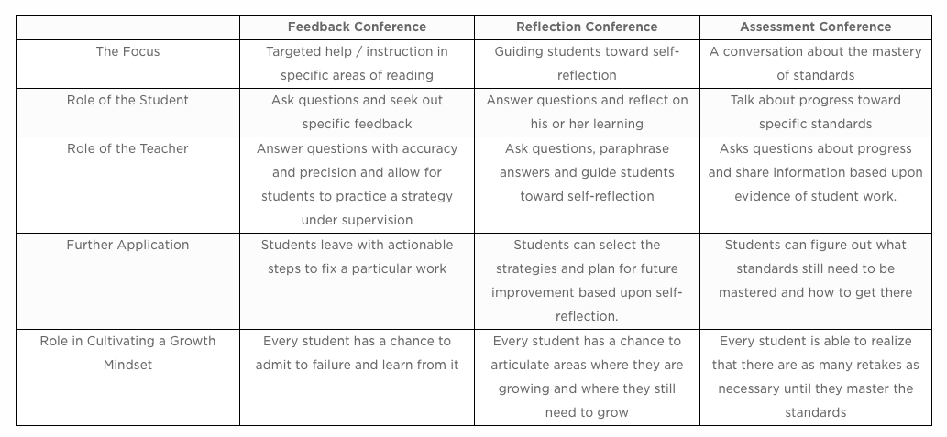

Advice Conferences
In the advice conferences, each student comes up with questions and asks specialized advice. Students look for specific feedback and focus on either getting critical feedback or finding solutions to a problem. It also allows the teacher to see issues that might be more intensive and require targeted tutoring.
The advice conferences help promote the mindset that every student in class still has room to grow. Instead of waiting for a teacher to say if something is right or wrong, students learn the art of asking for help. While we do not want students to become helpless and dependent, this conference style allows students to ask specific questions and seek out specific feedback from the teacher.
Sometimes these conversations begin with examining student work. Here, students might come with a list of clarifying questions that they realize need improvement. Other times, it might be a concept that they are still struggling with.
The following question stems can be a great help for students.
- I am having a hard time with ________ part of __________. Are you seeing the same thing?
- Could you show me how to _________?
- I’m going to practice _______ and I’d like you to tell me what you are noticing that I might be missing.
- I’m stuck with ________. What resources would you recommend for me?
- How could I improve on __________?
- I tried to do _____________, but it wasn’t working. What am I missing?
- When I ________, I sometimes have a hard time with ____________. How do I get past this?
- I’m still really confused with ___________, because ________.

Student Handout: Advice Conferences

Have you ever needed to ask your teacher for help but you were too scared? Or maybe you were wanting to ask for help but others were taking up his or her time? Well, now is your chance! Your teacher will be calling you up for an advice conference.
You will need to get your work (whether it is digital or paper) and take it with you to the conference. You will also need to think about specific advice you want to ask about. You might want to use the following stems:
- I am having a hard time with ________ part of __________. Are you seeing the same thing?
- Could you show me how to _________?
- I’m going to practice _______ and I’d like you to tell me what you are noticing that I might be missing.
- I’m stuck with ________. What resources would you recommend for me?
- How could I improve on __________?
- I tried to do _____________, but it wasn’t working. What am I missing?
- When I ________, I sometimes have a hard time with ____________. How do I get past this?
- I’m still really confused with ___________, because ________.

After the Conference:
List three next steps you want to take to improve your work.
1.

2.

3.

Reflection Conferences
The goal of a reflection conference is not about providing correction or giving practical ideas. Instead, the teacher asks reflective questions that encourage students to think about their learning. The following is a general guideline of how the reflection conferences work:
The conferences typically start out with the teacher reminding the student of the purpose of the conference (reflection). Next, it moves toward a discussion about strengths and weaknesses. It’s important here that the teacher doesn’t add any strengths or weaknesses. The goal is simply to get the student thinking, reflecting, and sharing. It ends with an articulation of goals and a plan for next steps. So, the general trajectory of the conversation moves from vague and personal to specific and practical.
In this conversation, it is important to avoid any type of feedback. We do not talk about scores or grades or the rubrics they have filled out. This can be tricky at first. Sometimes students are afraid of saying the “wrong” thing and will ask, “Is that right?” They might hedge their self-reflection with phrases like, “I don’t really know, but maybe . . .” However, the more they engage in reflection conversations the more they grow confident in their ability to self-reflect.
The following are some of the questions that I ask students in the this style of conference:
- What are some of the strategies that you have mastered? Why do you feel this way?
- In what area are you still struggling with?
- Describe your process when you __________. What is happening?
- What I’m hearing you say is _________. Is that accurate?
- Where are you growing? Are there any areas that you don’t see growth?
- How do you feel ________ is going? Is it turning out the way you had planned?
- What are some things you are noticing about _________?
- In terms of _________, what will success look like?
- What are you hoping to learn?
- What is an area where you would like to improve? What are some steps you will need to make to reach that?

Student Handout: Reflection Conferences
You will be participating in a reflection conference. The idea here is to think about how you are doing in this class. Your teacher will be asking you about your strengths and weaknesses and from there you will be able to talk about trends you see. Finally, you’ll think of the next steps you can take. The following are some of the questions that I ask students in the coaching conversations:
- What are some of the strategies that you have mastered? Why do you feel this way?
- In what area are you still struggling with?
- Describe your process when you __________. What is happening?
- What I’m hearing you say is _________. Is that accurate?
- Where are you growing? Are there any areas that you don’t see growth?
- How do you feel ________ is going? Is it turning out the way you had planned?
- What are some things you are noticing about _________?
- In terms of _________, what will success look like?
- What are you hoping to learn?
- What is an area where you would like to improve? What are some steps you will need to make to reach that?

After the Conference:

Strengths | Weaknesses

Next Steps:

1.

2.

3.
Assessment Conferences
The goal of an assessment conference is to examine student work (including rubrics and self-assessments) and have a conversation about mastery of standards. While the Advice Conferences involve students asking questions of the teacher and the Reflection Conferences involve the opposite, these conversations tend to be more of a give-and-take.
Sometimes it works best to start with asking students what they feel they have earned and why. Other times, it helps to start with an open grade book and the question, “Do you feel this is accurate?” Still, other times, it works best to examine a project rubric filled out by both the teacher and the student and then compare and contrast perceptions. I have also included a template for the Standards-Based Assessment Grid. This is a document I have used in assessment conferences when I wanted to focus to be on specific standards.
Ultimately, the goal is for students to know which standards they have mastered and where they need to go from there.
The following are some of the questions that I ask students in the assessment conferences:
- How do you feel that you have done on this standard? What level of mastery would you give yourself? Why?
- Is this an accurate representation of what you have learned?
- Which standards do you need to focus on in order to improve? What help do you need? Where will you look?
- Which standards are you excelling at? What kind of enrichment would you like to pursue in those areas?
- How will you know when you have mastered (name the standard)?
- What are the next steps you need to take in order to master (name the standard)?

Student Handout: Assessment Conferences

You will be examining your work as you have a conversation about the mastery of standards. You might be looking at a project rubric or a self-assessment or perhaps even a progress report. The goal is for you to figure out where you still need help, where you could move to a higher level of proficiency and where you can build upon your expertise.
Here are some of the questions your teacher might ask you:
- How do you feel that you have done on this standard? What level of mastery would you give yourself? Why?
- Is this an accurate representation of what you have learned?
- Which standards do you need to focus on in order to improve? What help do you need? Where will you look?
- Which standards are you excelling at? What kind of enrichment would you like to pursue in those areas?
- How will you know when you have mastered (name the standard)?
- What are the next steps you need to take in order to master (name the standard)?

After the Conference:
What is one standard where you are struggling? What are two things you will do to master this standard?

What is one standard where you are exceeding? What enrichment do you want to do to take it to the next level?

SELF-REFLECTION QUESTIONS

FORMAT:
The first approach is to use these self-reflection questions in Google Forms. You can also add quantitative elements (such as “rate how you did on a scale of 1-10” or “Checkmark every word that describes how you feel about your work”). I love the fact that you can look at general trends throughout the class. In terms of timing, these work well as a warm-up, a mid-lesson break, or an exit slip. An alternative approach is to use these questions in the form of a blog.

QUESTIONS
- How do you feel about your work? What adjectives would you use to describe your feelings toward your finished product?
- What would you improve if you had more time?
- What are you the most proud of?
- What did you learn along the way? Describe any new skills or concepts you acquired.
- What did you learn about yourself based upon this experience?
- What part was the hardest for you? Why?
- What part was the easiest for you? Why?
- Would you do something similar to this in your free time? Why or why not?
- How could you build on this assignment or project in the future?
- What are your next steps?

PEER FEEDBACK SENTENCE STEMS

COMMENTS AS QUESTIONS
Why did you _______________?
What made you think of writing _____________________?
Have you considered ______________________?
Is it possible that ________________?
Have you considered the possibility that ____________?
I was wondering why _________________?

COMMENTS AS STATEMENTS
Agree / Disagree
I agree that _______________ because _______________.
I disagree with your thought that _______________ because _______________

Clarifying
I was a little confused about _______________. Could you explain _______________?

GROUP FEEDBACK QUESTIONS

THE BASICS:
These can be used as students guide the reflection during the testing and revision phases.
Clarifying
What process did you use? Why did you choose to use that process?
How did you make that? What was your thinking behind it?
What clues helped you find that?
Can you explain what you were thinking?
What part was challenging for you? How did you get past the challenge?

Analytical Questions
Why does your process work? Is there a scenario where that might not work?
What can you do to prove to me that your process was correct?
Is there another way to look at this?
How did you arrive at that conclusion?
Is there a more efficient way to do this process?

Diagnostic Questions (If You’re Stuck)
What did you do to get to that point?
What part are you struggling with?
What part isn’t working? What could you do to improve it?
Is there another strategy you can use from another math process?
What do you already know? Can you build on this?
What information are you missing?
Is your prototype working?

