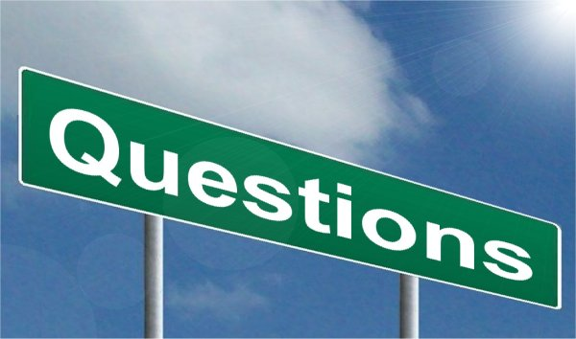

- Tell me about what you’re thinking?
- Where did you get your idea from?
- Why do you think?
- How do you know?
- Why do you think this happened?
- What will happen next?
- How did this happen?
- What can you do about it?
- What do you think would work?
- How do you think it could work?
- Can you do it another way?
- How are these the same?
- How are these different?
- What do you think comes next?
- What else can you do ?
- What does it remind you of?
- What was easy?
- What was the hard?
- I wonder why?
- Why did you?
- How did you do that?

Teacher as observer / researcher

- What is really happening here?
- What might they be thinking?
- What are they demonstrating / revealing
(skills, curiosities, capabilities)?
- What does this tell me about the child/ren
- What might they need to facilitate / extend
their thinking and learning

Noticing and Naming

- I noticed that you….
- I can see you….
- Looks like you…..

