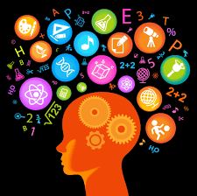
Tracking my Learning
What skills have you developed or used during your project?

PERSONAL AND SOCIAL CAPABILITY | CRITICAL AND CREATIVE THINKING
Self-Awareness and Management  - I can name my personal strengths and learner dispositions  - I can reflect on how I use my personal strengths and learner dispositions  - I can set goals to further develop my personal strengths or learner dispositions  - I can use persistence and resilience when dealing with new or challenging situations  - I can name and describe the skills needed to work independently  - I can reflect on what I did well and what I need to improve when working independently  - I can describe my learning using the language of learning  Social Awareness and Management  - I can work effectively in groups  - I can take on different roles when working in a group  - I can evaluate myself and my group by saying what I/we did well and what I/we need to improve  - I can suggest solutions when our group is not agreeing with each other | Questions and Possibilities  - I can create a range of questions to effectively guide my inquiry  - I can generate creative and imaginative ideas and possibilities  - I can generate alternative ideas to solve problems  Reasoning  - I can put forward my point of view when pitching my own idea or giving feedback to others  - I can sort and organise new information from a range of sources  - I can create and use criteria for the success of my project  Meta-Cognition  - I can use a range of thinking strategies eg:  - Visualising ideas,  - Note-taking, summarising and paraphrasing,  - Learning from peers,  - Breaking tasks or problems into smaller steps,  - Reflecting,  - Evaluating and testing  - I can use and follow an inquiry process eg:  - Design Process  - Research Process  - Scientific Process  - Problem-solving Process  - Arts Process  - Field-study Process

