Beginning of the year Discovery Ideas…

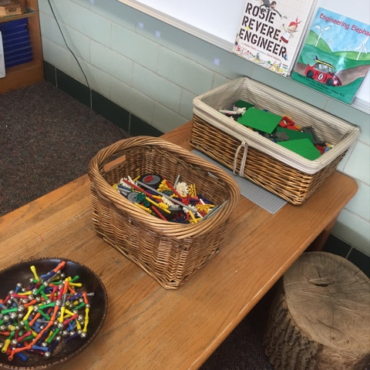
The Physical Environment -Setting up the learning area to foster wonder, creativity and exploration:

Open ended play spaces
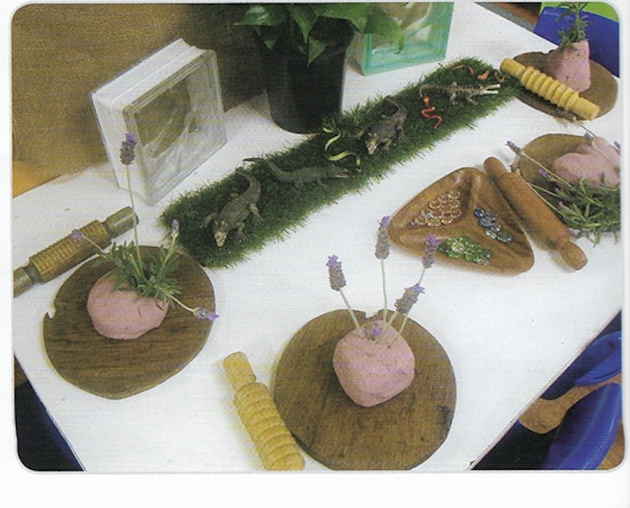
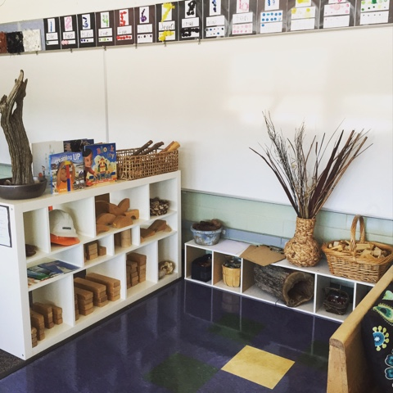
Access to equipment and resources so students can find what they need - this also assists with the clean up and packing routines at the beginning
Natural and open-ended resources
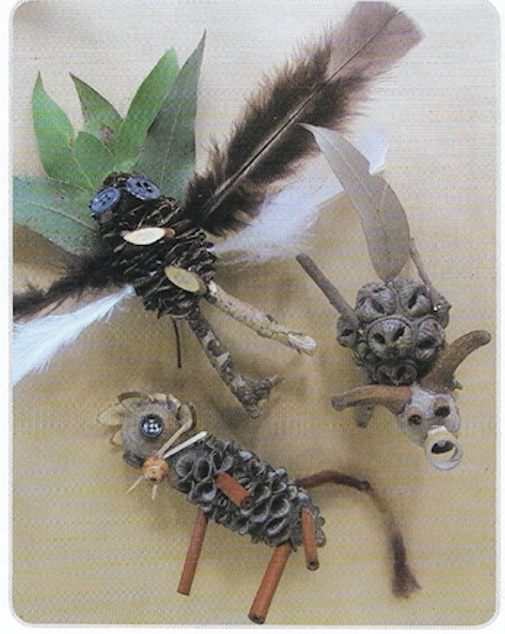
Define areas by arrangement of furniture, use of rugs etc. Distinct spaces help children to know exactly what materials are available in each area and ways they can use those materials
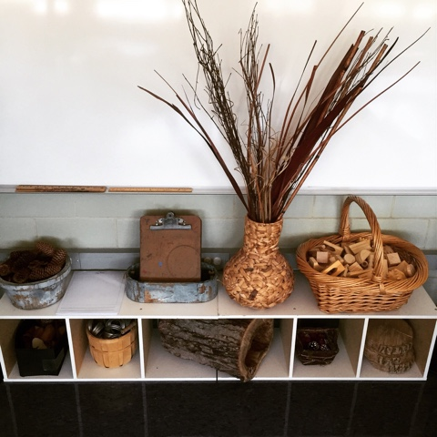
Connect home and school environments (creating softness, home-like)
Consider starting with bare walls, or a more ‘minimalist’ approach and be open to the students co-creating and constructing the environment alongside you

“We are not decorating learning spaces. We are designing them to amplify learning”
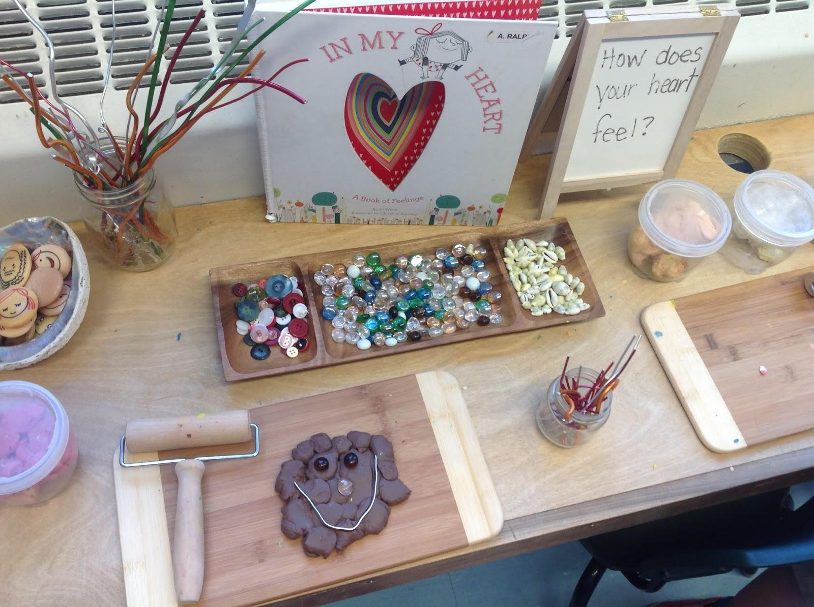
The Space - Rebecca Louise Hare

Loose parts - open ended materials that are varied in color, texture, size, shape and can be used in varied ways for multiple purposes.
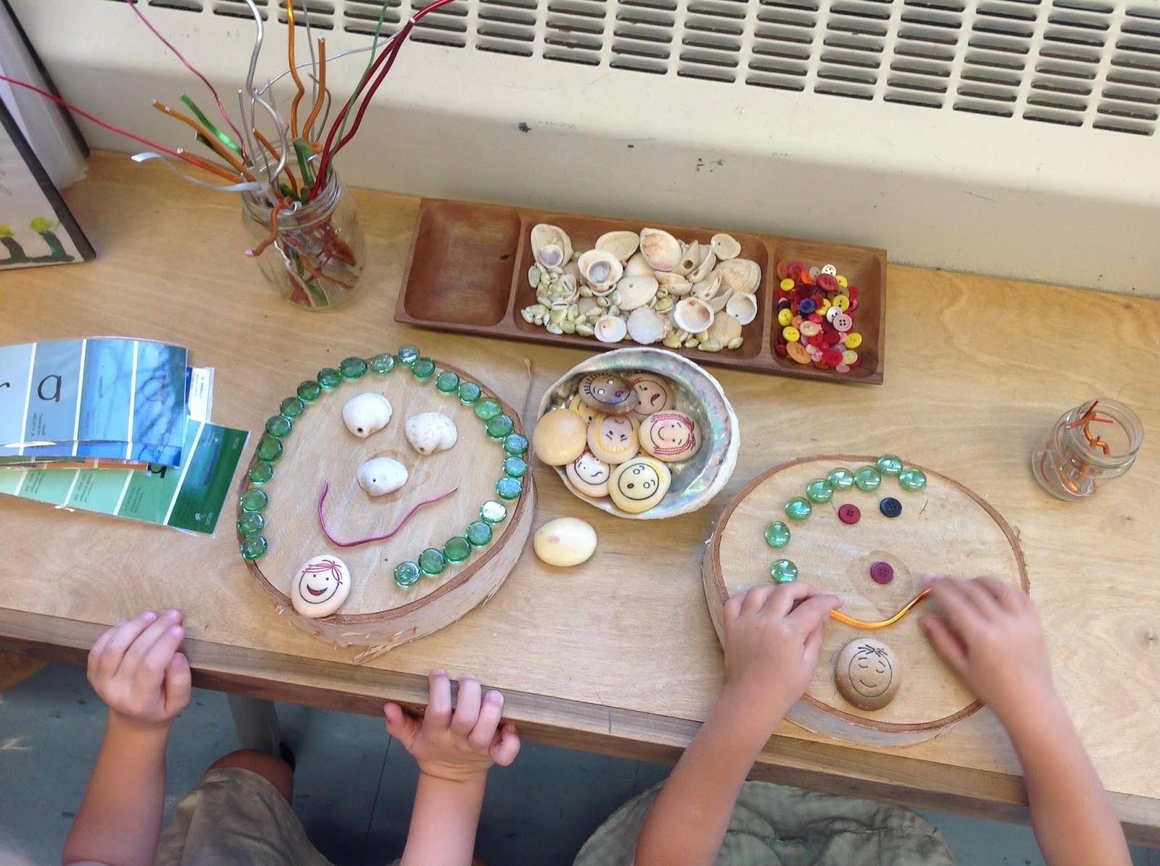
Start with very small amounts to begin with as you build your expectations in regards to their use and how we pack them away - then you can increase supplies as students show they are ready

Some initial ideas for the beginning of the year

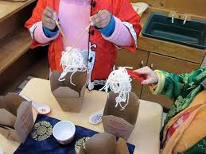
Role Play/Dramatic Play - Consider what you put in these areas - open ended materials allow for symbolic play - encourage imagination and creativity, rather than commercially produced items that are closed
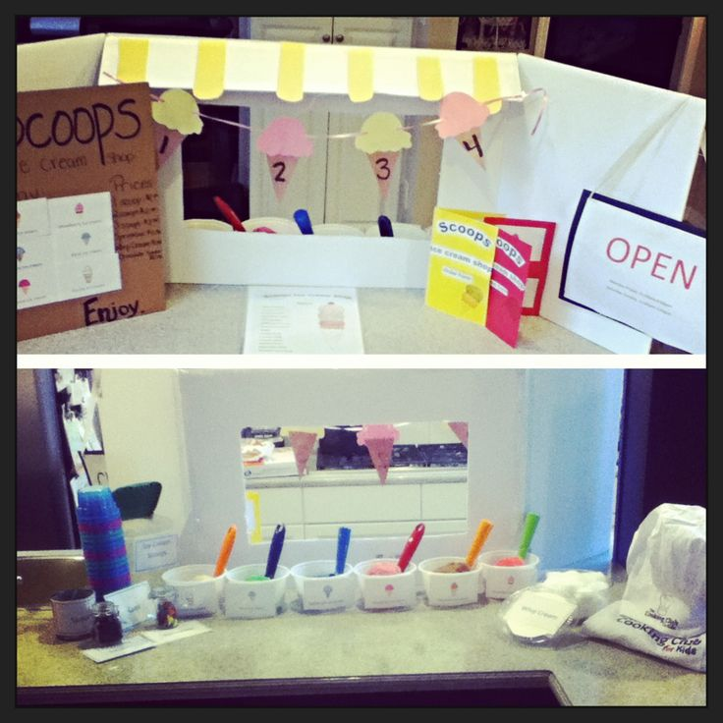
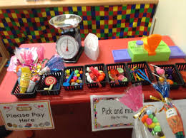
Home Corner, Cafe/Restaurant (pizza, noodle bar, burger bar), lolly shop, Holiday related (i.e. camping, beach, airport, train station, ice cream shop) school and areas in the school, 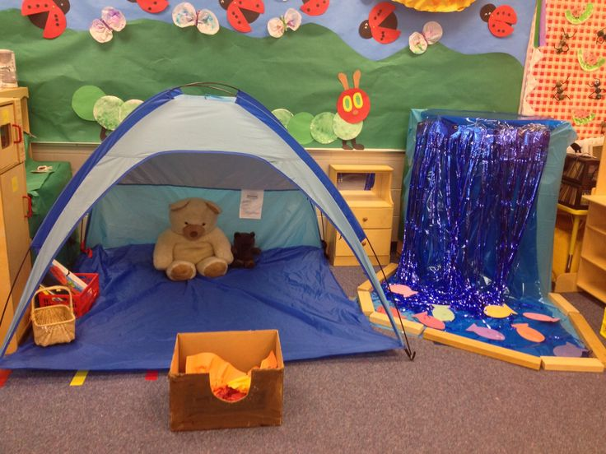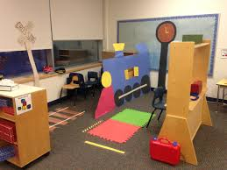

Sensory Play- sensory opportunities can be included in any area you set up but you can also have specific sensory areas to encourage and support specific explorations
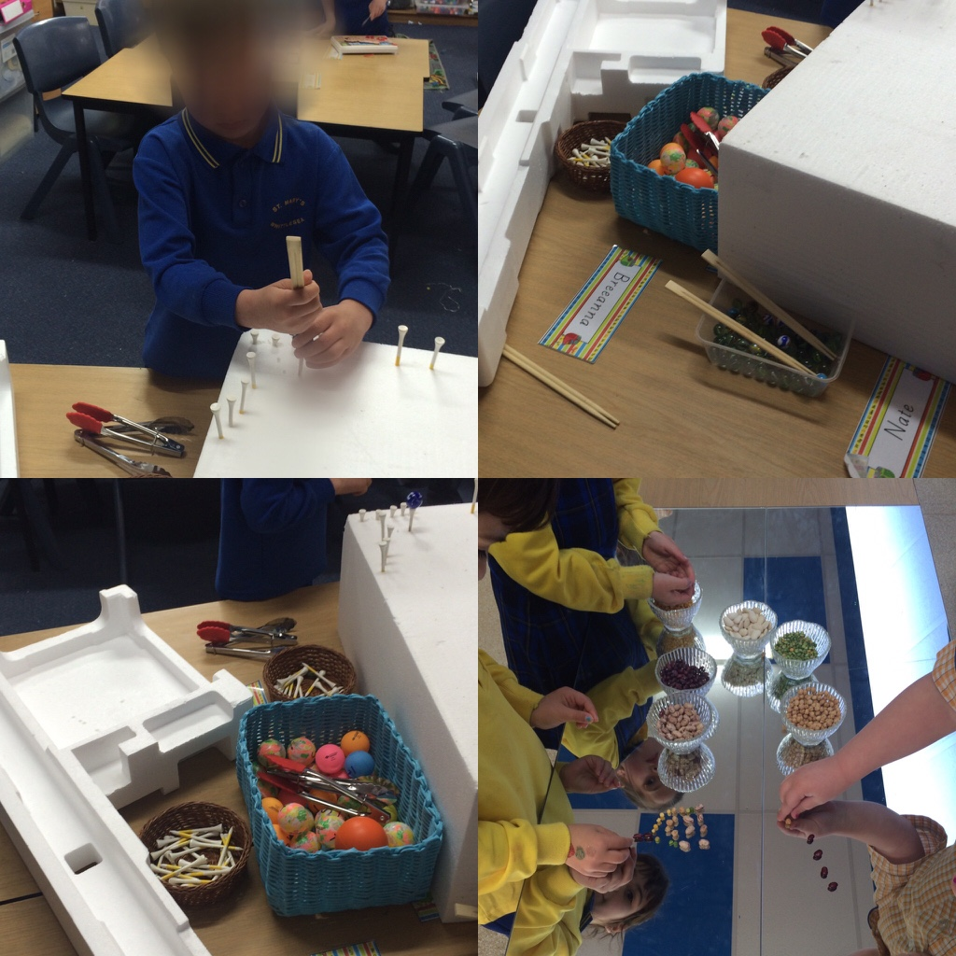
Consider - water, sand, rice, playdough, water beads, ice, rubbery goop
Fine motor (Prep) - threading, playdough, tweezer challenges, smaller loose parts (pincer grip)
Drawing/Writing - Drawing is a symbolic language used by children to express ideas and is the link between what children think they can communicate in some way - I can think it, I can draw it and this can help me say it, and then eventually write it.
Consider - Variety of writing implements- pens, pencils, textas, glitter pens, Different types of paper and different sizes, Paper cut into different shapes, Stapler, Envelopes, Stamps, Chalk and chalkboards, Whiteboards and whiteboard markers
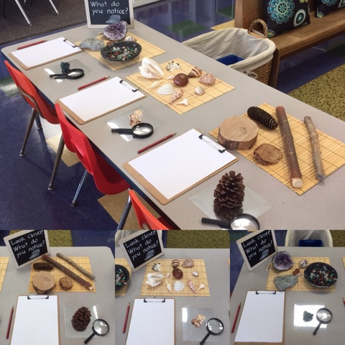
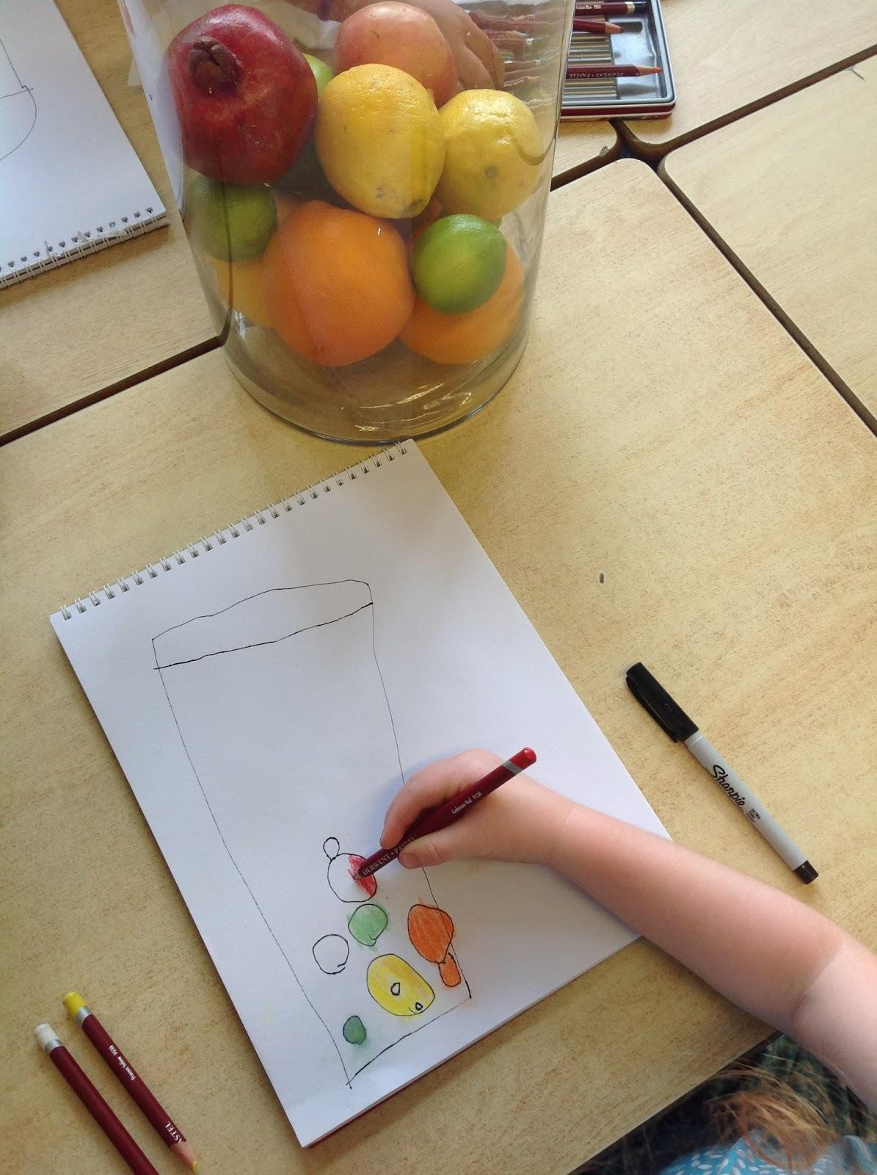
Observational Drawing: sketching and drawing tools arranged by colour, less is more - encourages children to observe closely and record exactly what they see - working as scientists observing the world through their senses

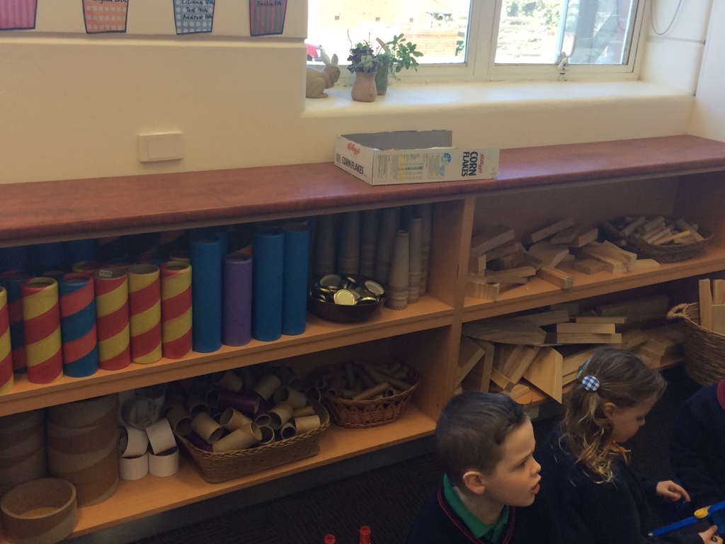

Construction - wooden blocks, large plastic cups, cylinders, magnetic blocks, marble runs, Duplo,
Small World - through these miniature worlds, children can create and recreate their own representations and explore concepts in a concrete way - incorporate loose parts and natural materials wherever possible
Story Tables - similar to small worlds, these allow children to revisit familiar texts that have been read to them or shared - they can retell the story or improvise and imagine their own story. The text can come from the teacher, the student interest or connected to the inquiry investigation. Texts with repetition and strong plots work the best and children can practice language in flexible ways (Lisa Burman Booklet has additional information)

